

MIDDLE EAST TECHNICAL UNIVERSITY

Electrical and Electronics Engineering Department

EE568 Selected Topics on Electrical Mahines

PROJECT 1

TORQUE IN A VARIABLE RELUCTANCE MACHINE

Enes AYAZ 2093318

# Introduction

In this project, the torque characteristic of a variable reluctance machine is investigated. Reluctance machines are electrical machines which are not required additional rotor winding or magnets on rotor. The rotor of the reluctance motor is ferromagnetic material and its reluctance changes with respect to position of rotor. The changes on reluctance creates torque which led the machines rotate. The machines are used for high power density and low cost thanks to not having additional winding. However, the torque ripples of the machines are higher than other rivals such as permanent magnet synchronous machines. In the project basic two pole reluctance machines are investigated. The machines are shown at figure 1.

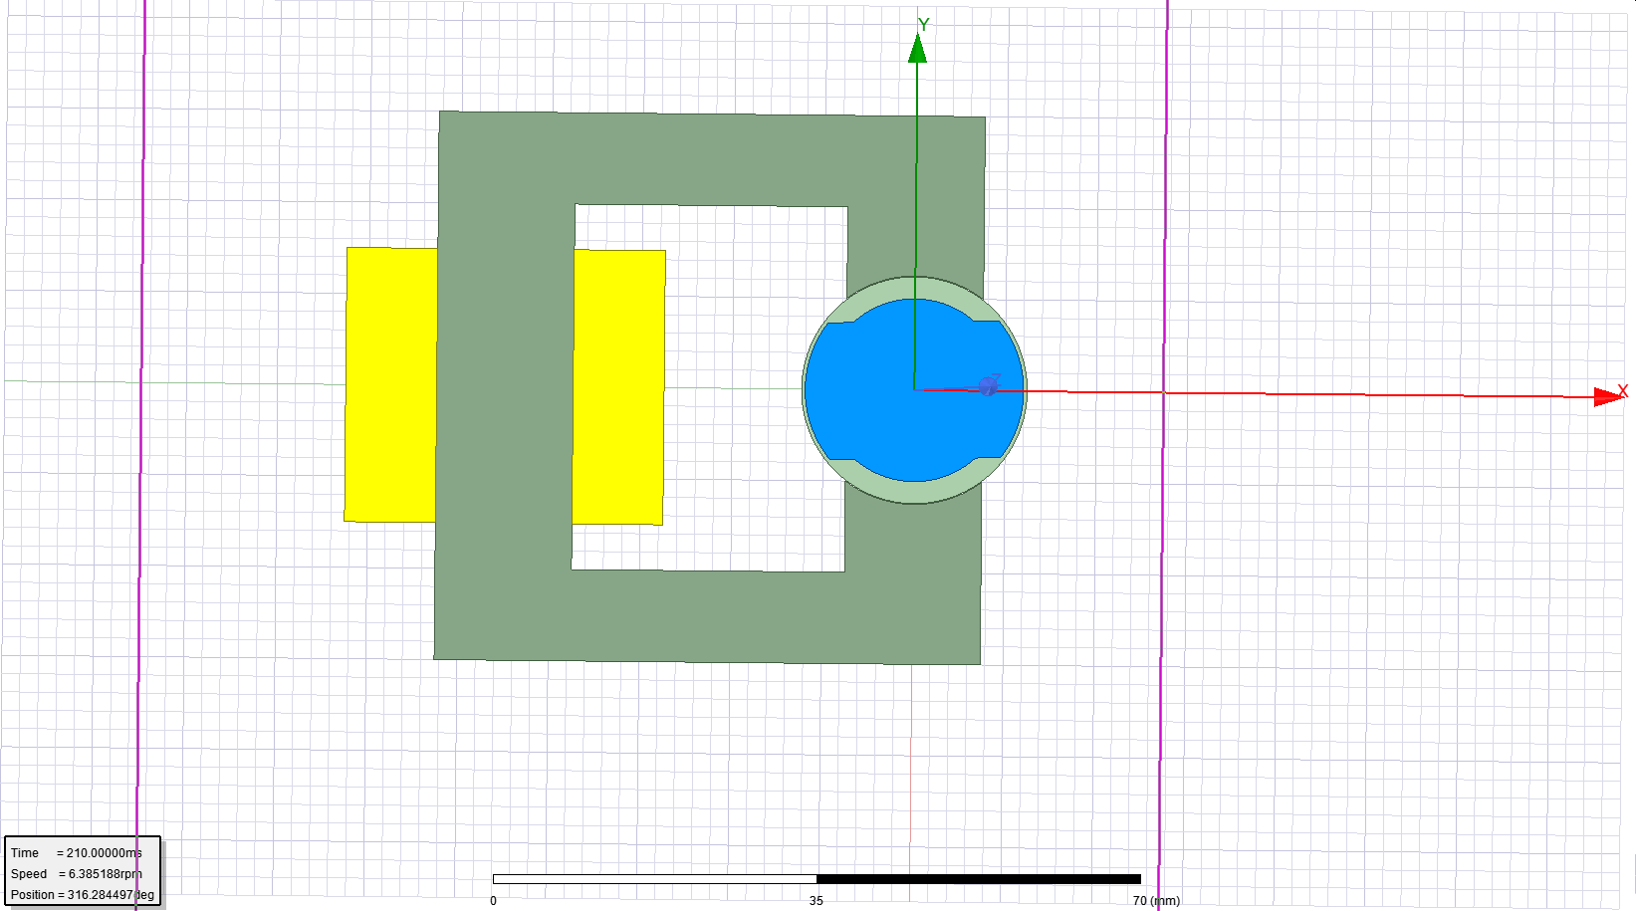

Figure Variable Reluctance Machine (coils, stator, rotor is represented yellow, dark green and blue respectively)

In this report, there are four section. Firstly, an analytical model of the machine is created. Inductance and reluctance of the machine are formulated and torque is found for constant DC excitation. Secondly, 2D finite element analysis with linear material is made by using Ansys Maxwell software. In this part, flux density vectors for different rotor positions are plotted. Also, inductance and storage energy are calculated for the positions. The torque is formulated by results of FEA analysis and the analytical model and FEA results are compared. Thirdly, FEA analysis is repeated with non-linear material. Also, comparison between linear and non-linear material is made. Finally, control methods are investigated to drive the motor properly with net torque component.

# Analytical Modelling

The machine has variable reluctance with respect to rotor position. The variable reluctance actually depends on changing air gap between stator and rotor. In figure 2,the machines dimensions are shown.

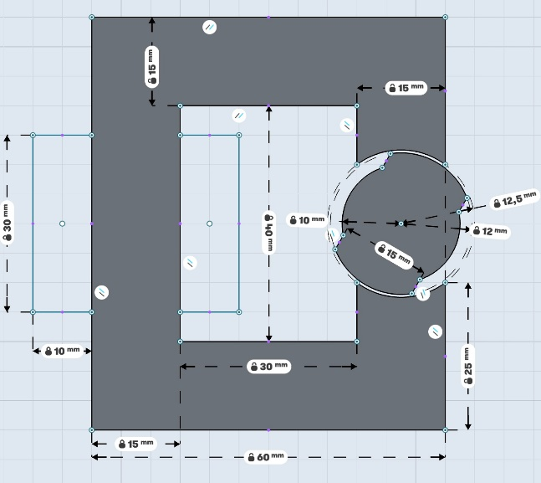

Figure Dimensions of the machines

Derivation of the reluctance and inductance of the system is required to formulize the airgap of the machines with respect to rotor position. Rotor position is created by taking zero angle at maximum inductance, so minimum airgap. Also, zero angle can be named as direct axis and 90-degree angle can be named as quadratic axis. To create a function of the airgap with respect to position, we can divide the positions (named ) into regions and use the direct axis airgap(ld), quadratic axis air gap(lq). In the figure X, ld and lq are 0.5mm and 2.5 mm. The calculations are based on some assumptions such as infinitely permeable core, no nonlinearity and non-fringing effects and ld includes 160 degree and lq included 200 degree for fully rotated mechanic angle.

|  |  |  |  |
| --- | --- | --- | --- |
| Region | Minimum Angle | Maximum Angle | Formulation(airgap) |
| A | 0 | 80 |  |
| B | 80 | 100 |  |
| C | 100 | 180 |  |

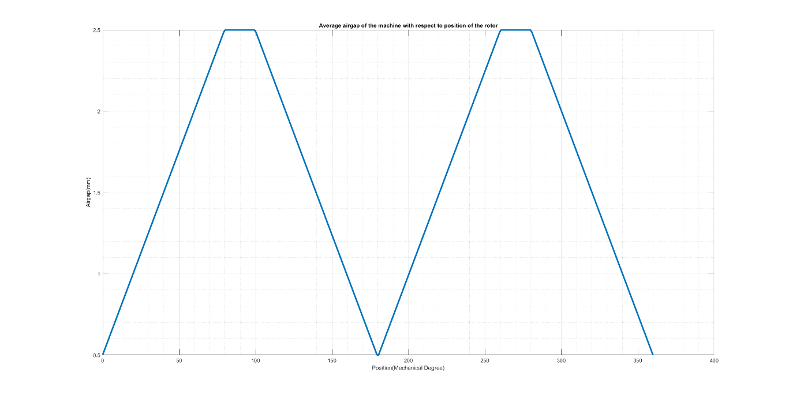

Figure Effective airgap distribution of the machine with respect to rotor positions

A, B, C region is enough to calculate the reluctance and inductance of the system because the system airgap is symmetric and it repeats two times for total mechanical angle. By using the airgap formulation, we can calculate reluctance and inductance by air permeability and area of the pole. Area of pole can be calculated by axial length () of machines and radius () of the stator space.

|  |  |  |  |
| --- | --- | --- | --- |
| Region | Minimum Angle | Maximum Angle | Formulation (Reluctance) |
| A | 0 | 80 |  |
| B | 80 | 100 |  |
| C | 100 | 180 |  |

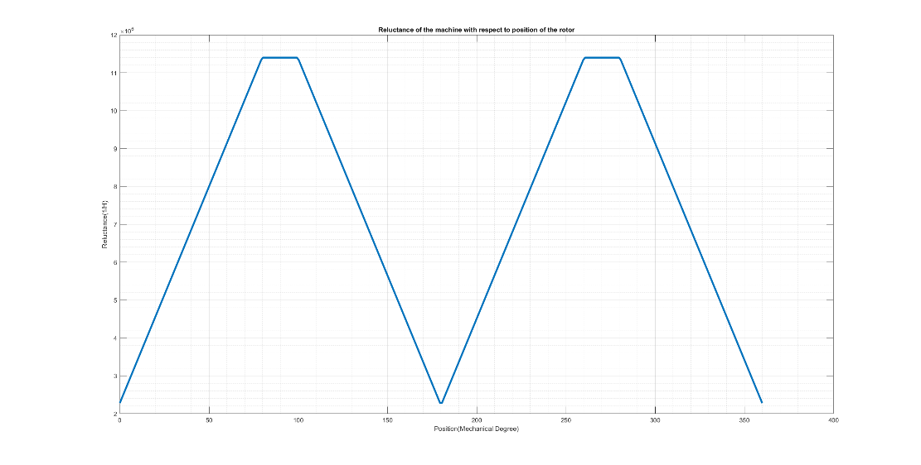

Figure Reluctance of the machine with respect to rotor positions

|  |  |  |  |
| --- | --- | --- | --- |
| Region | Minimum Angle | Maximum Angle | Formulation (Inductance) |
| A | 0 | 80 |  |
| B | 80 | 100 |  |
| C | 100 | 180 |  |

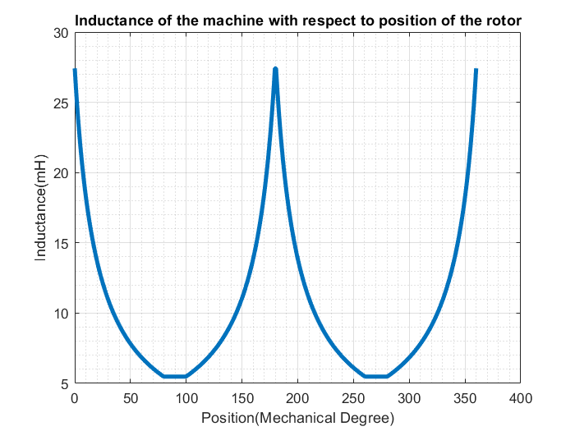

Figure Inductance of the machine with respect to rotor positions

By assuming constant current excitation, torque can be calculated as:

Current is constant and taken as 3A for each turn.

|  |  |  |  |
| --- | --- | --- | --- |
| Region | Minimum Angle | Maximum Angle | Formulation (Torque) |
| A | 0 | 80 |  |
| B | 80 | 100 | 0 |
| C | 100 | 180 |  |

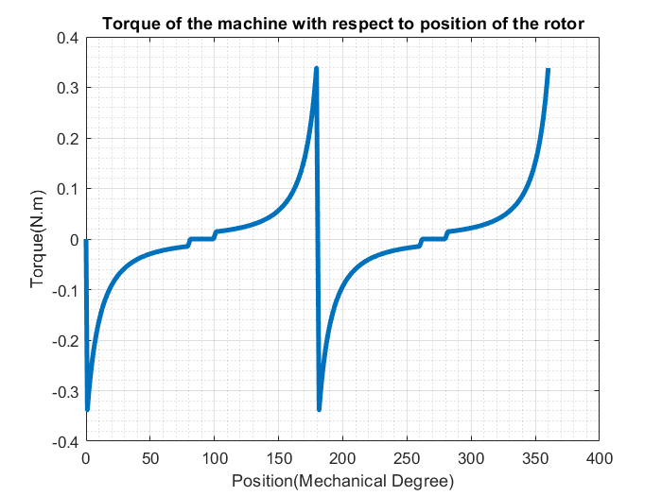

Figure Electrical Torque of the machine with respect to rotor positions

The analytical model can be used to obtain fast solution and the results are not entirely correct. However, the analytical calculation can be improved by changing some assumptions. Firstly, infinitely permeable core can be changed as realistic core and the reluctance due to the core can be added to the model. Also, saturation of the core can be added to model for highly excited situation. In addition, fringing effect increase the effective core area and inductance too. The fringing effect can be added to model.

# FEA Modelling (2D – Linear Materials)

In this part, finite element analysis of reluctance machine is investigated. Flux density for different positions are found and inductance and stored energy in the system are calculated. Simulation environment for FEA is chosen Maxwell 2D. Transient solution is chosen to observe rotation of the machine.

Figure X shows the model of the machine. Rotor is blue part and the position In the figure X is chosen as -45 degree. Green is stator core and the material of the rotor and stator is chosen as Iron. The material is linear and relative permeability is 4000. Yellow part is coils. The coils are chosen as stranded and it draws 3A in the direction inside and out of page. Turn ratio is 250. The model is run in transient solution to observe the rotation with respect to time.

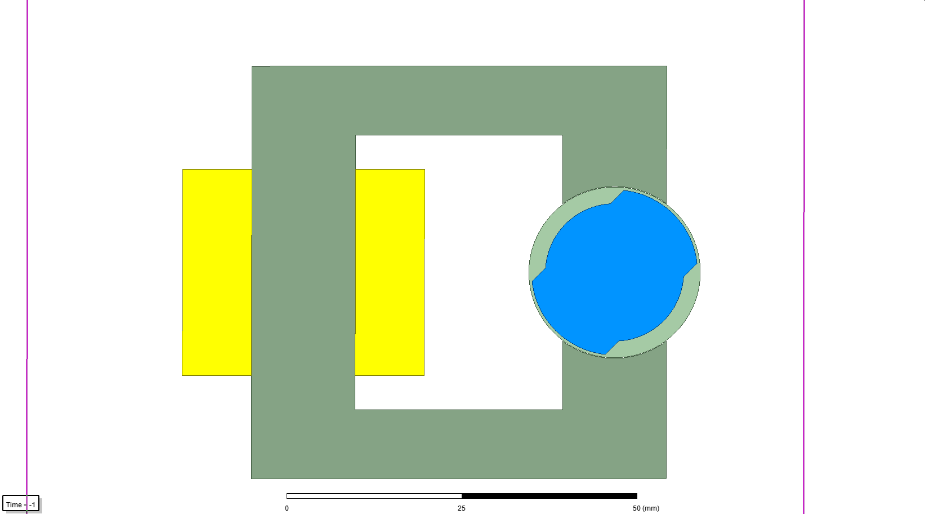

Figure Model of the machine

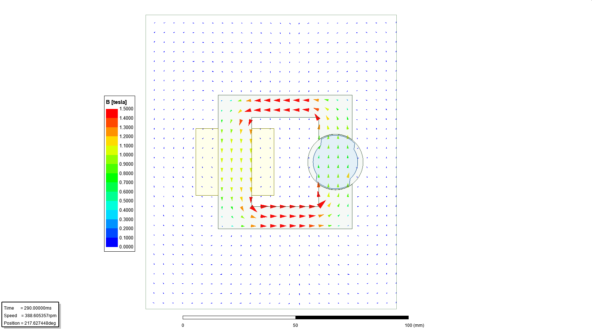

Figure Flux distribution vectors or rotor position is 0 (aligned with d axis)

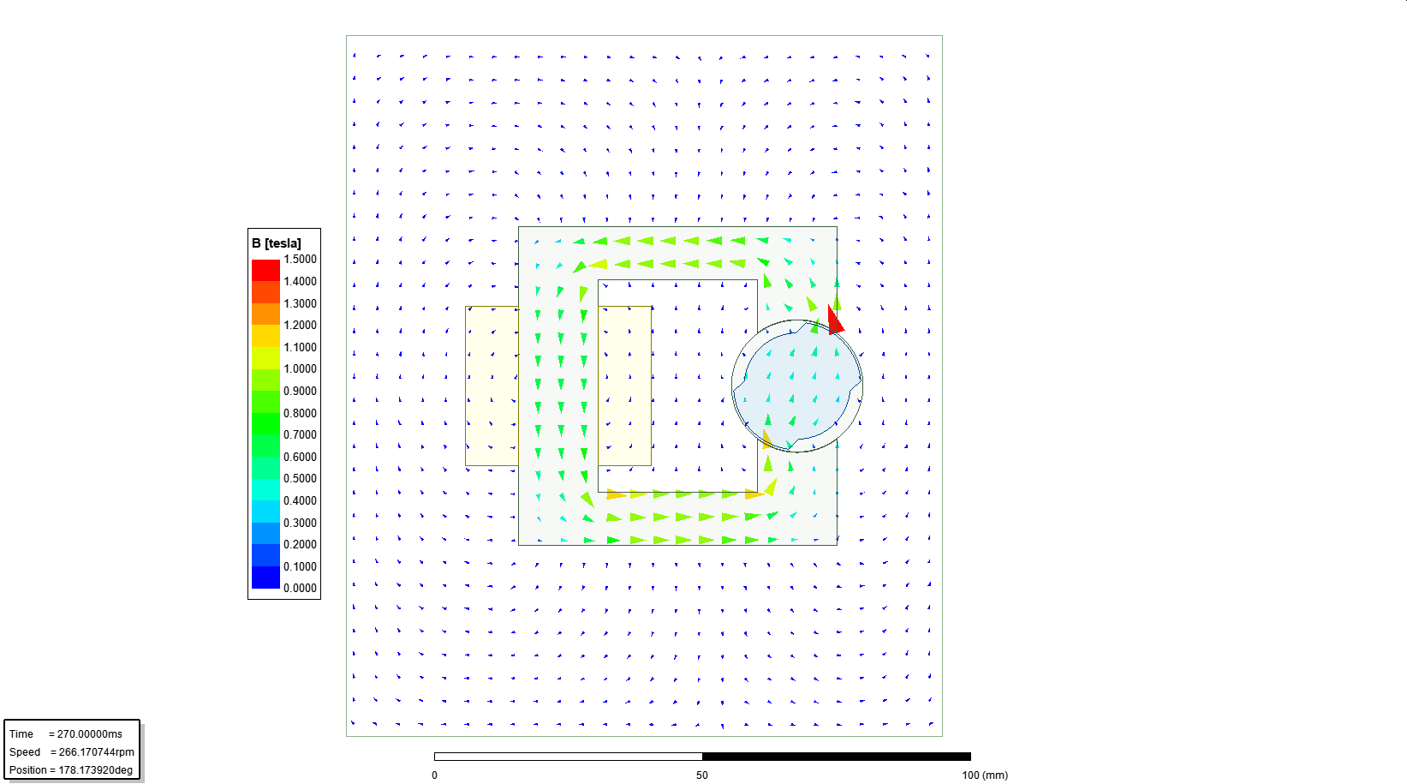

Figure Flux distribution vectors for rotor position is -45

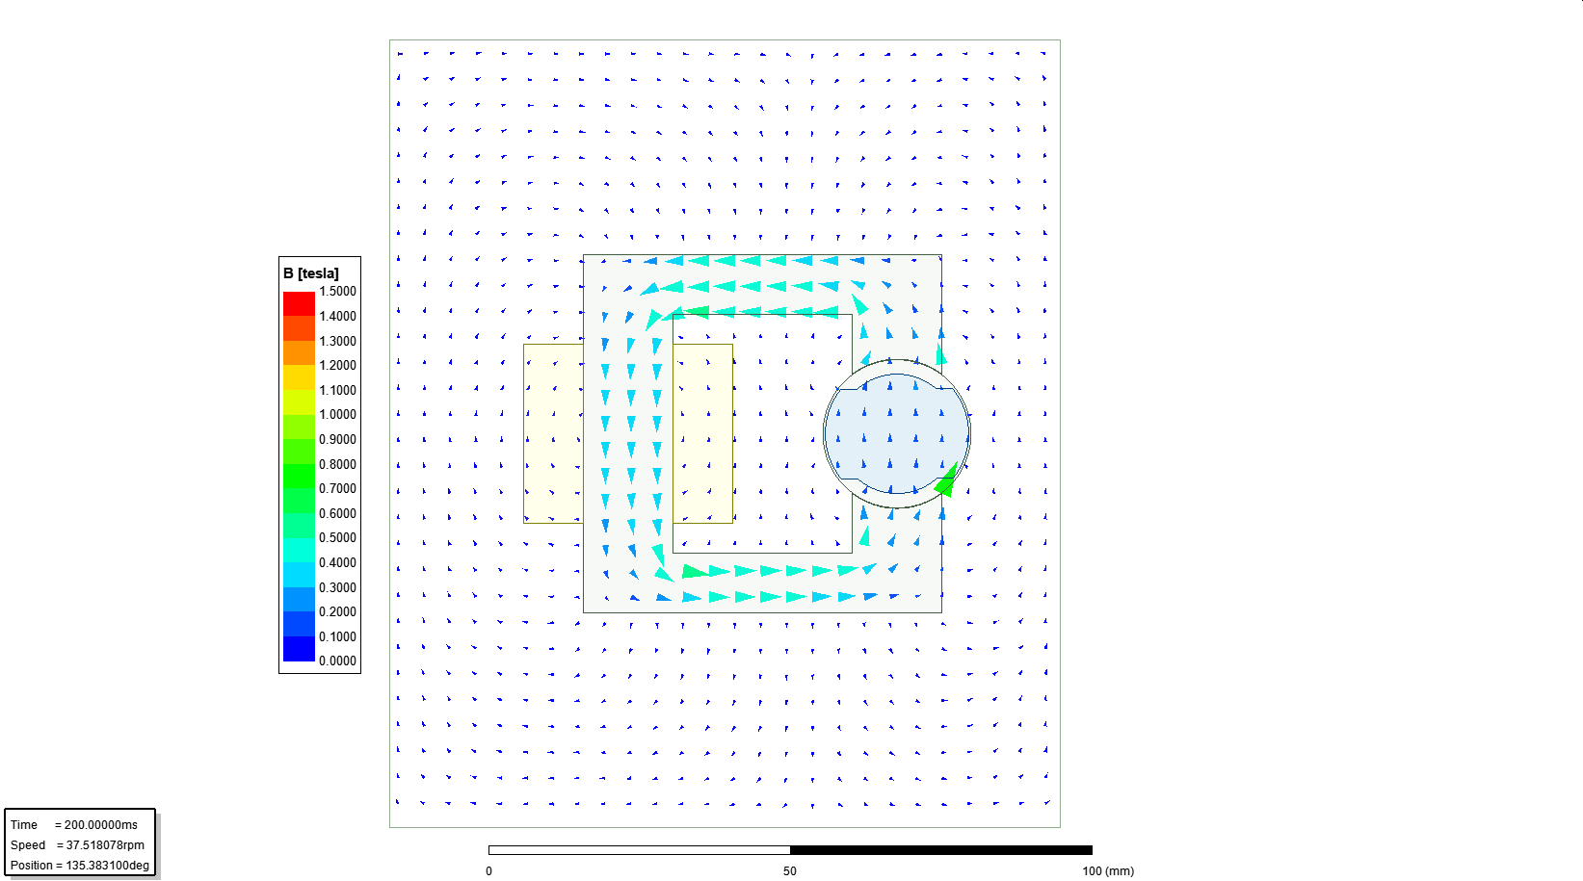

Figure Flux distribution vectors for rotor position is 90 (misaligned with d-axis)

Figure 8,9,10 shows the magnetic flux distribution for different rotor positions respectively 0, -45, -90. For different rotor positions, the reluctance of the system is changed. By considering constant MMF (DC excitation), it is expected to variable flux density. In figure 8, reluctance is minimum that gives maximum flux density. The position can be named as fully aligned.

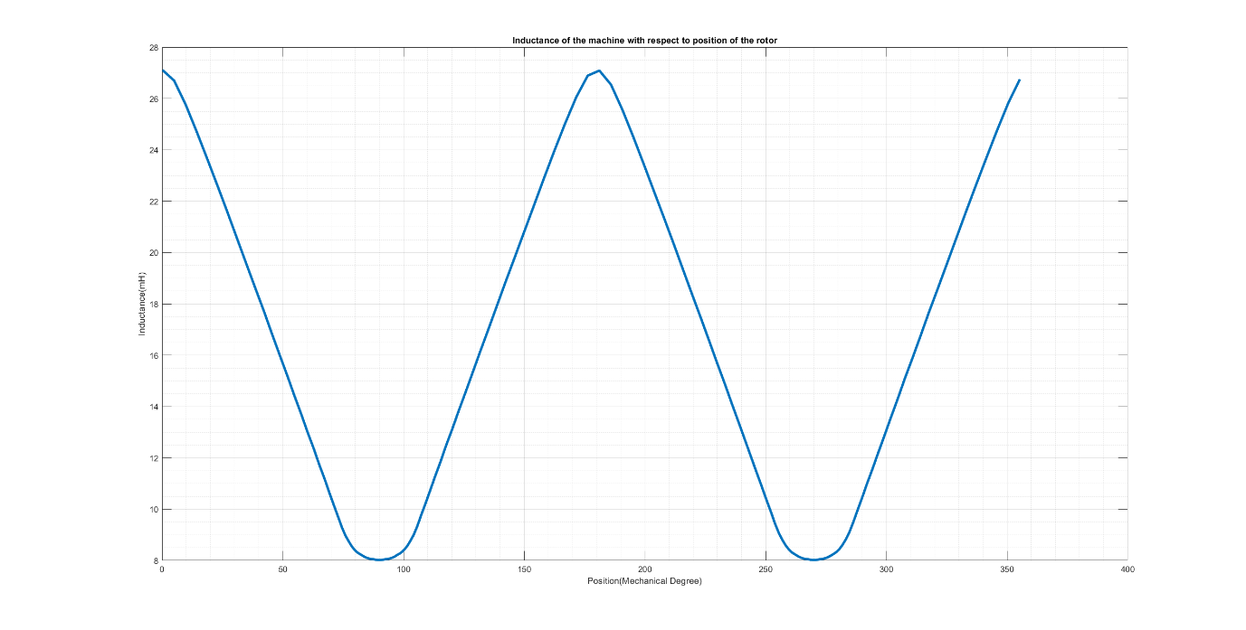

Figure Inductance of the machine with respect to rotor positions

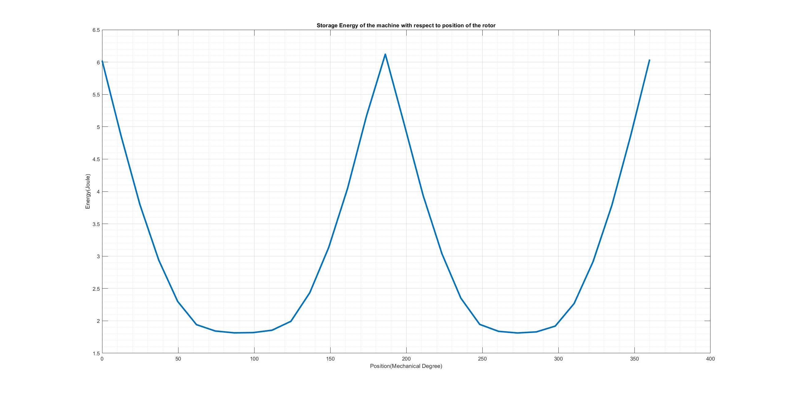

Figure Stored energy of the machine with respect to rotor positions

In figure 11 and 12 shows that fully aligned position have maximum inductance and energy. Also, energy function with respect to rotor positions is proportional to square of inductance

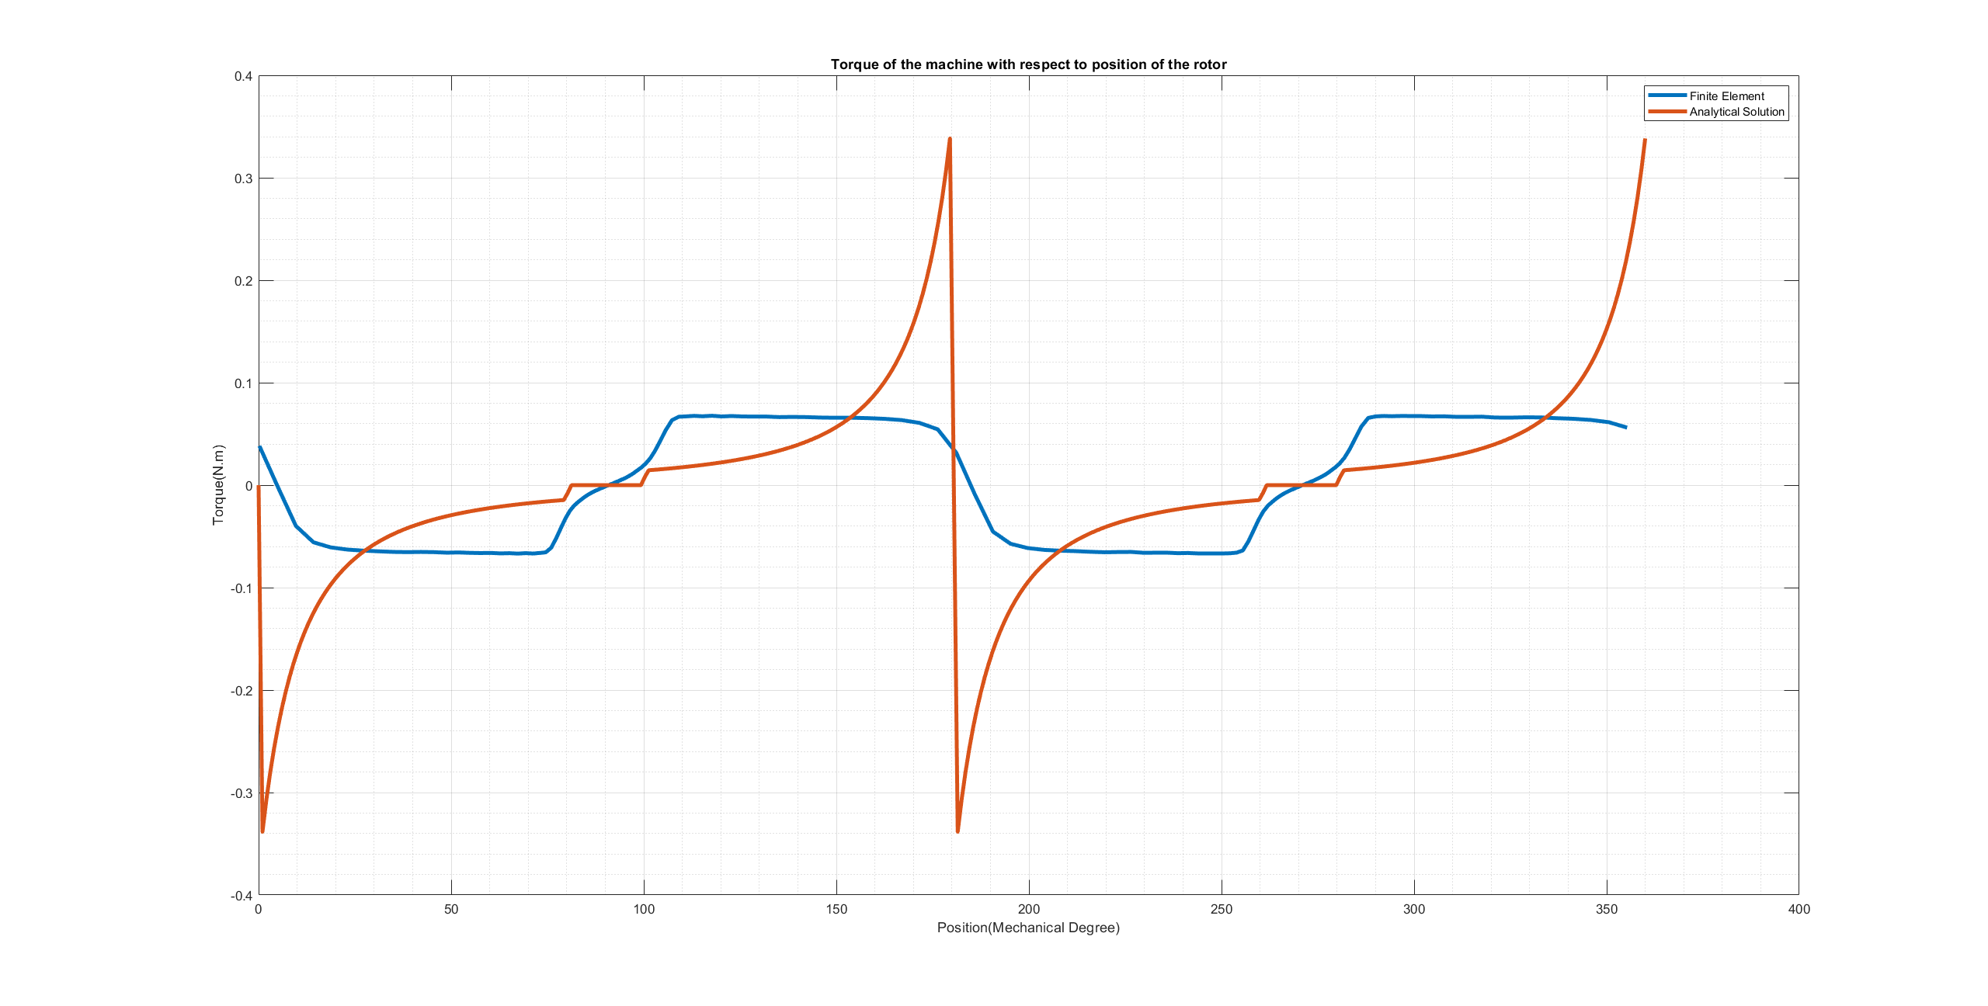

Figure Comparison of Electrical Torque of the machine with respect to rotor positions

|  |  |  |
| --- | --- | --- |
| Model | sin( ) | sin(4 ) |
| Analytical | 76.46 mN.m | 55.67 mN.m |
| Finite Element | 80.13 mN.m | 3.7541 mN.m |

In figure 13, analytical and finite element analysis for electrical torque are given. Although the torque lines seem as different, fundamental components are almost the same. For the assumptions in analytical model led the torque have bigger second harmonic.

# FEA Modelling (2D – Nonlinear Materials)

In this part, nonlinear material is used in stator and rotor. The simulation results are changed becaues the nonlinear material permeability is smaller than linear material that is used. In our system, NI is not enough to saturate core. Thus, it is not observed saturation effect. The results are shown at figure 14,15,16,17,18,19.

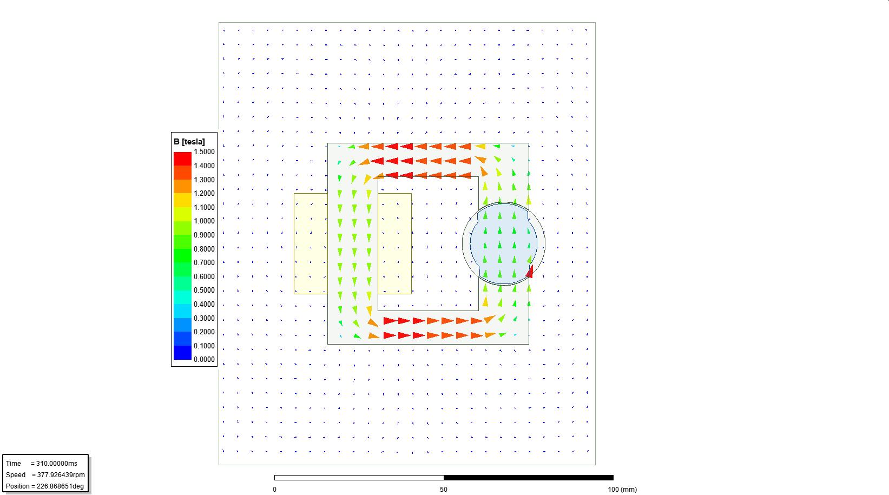

Figure Flux distribution vectors or rotor position is 0 (aligned with d axis)

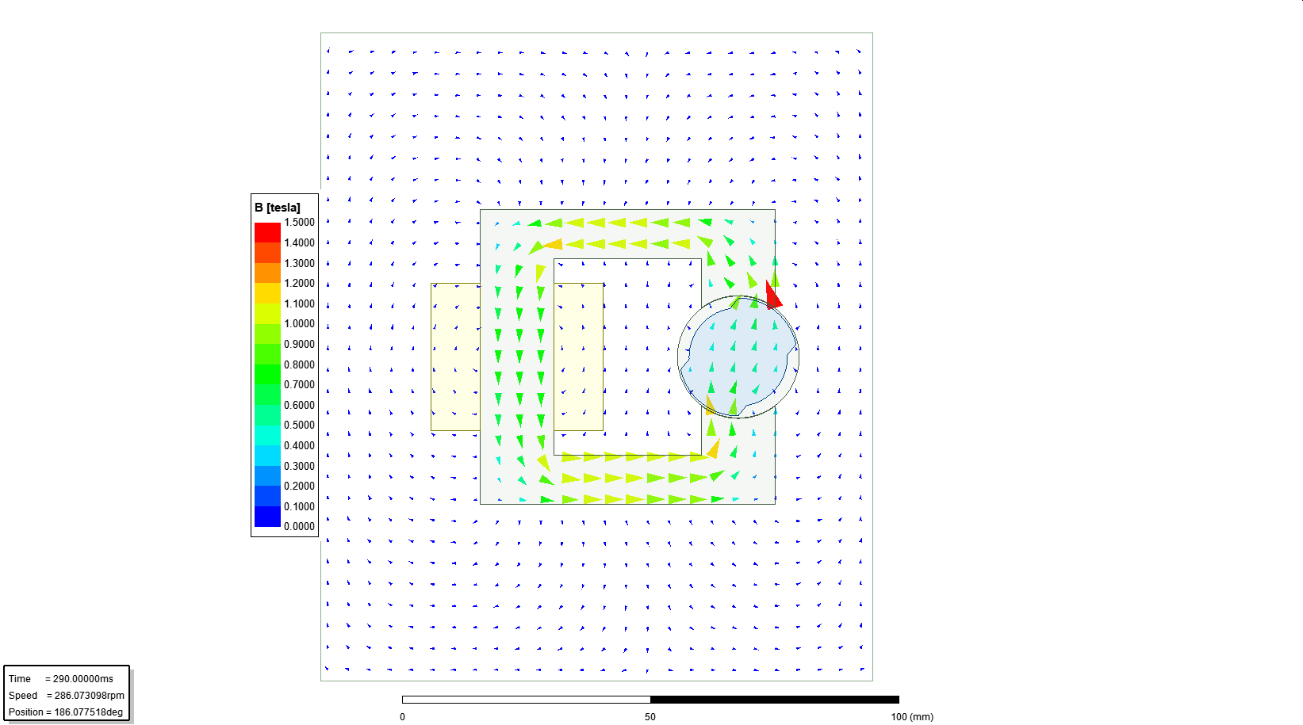

Figure Flux distribution vectors for rotor position is -45

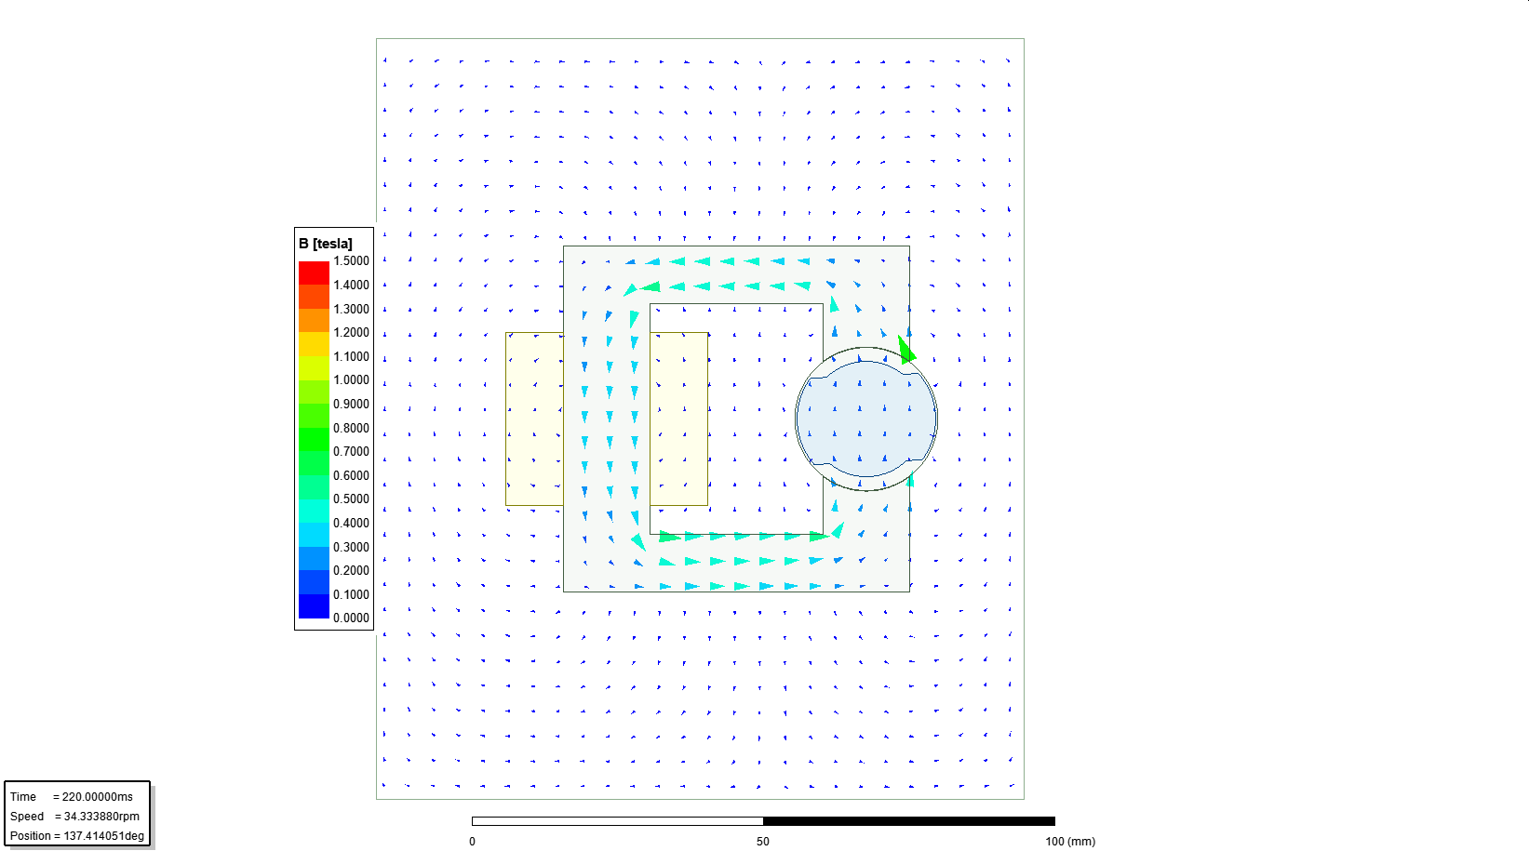

Figure Flux distribution vectors for rotor position is 90 (misaligned with d-axis)

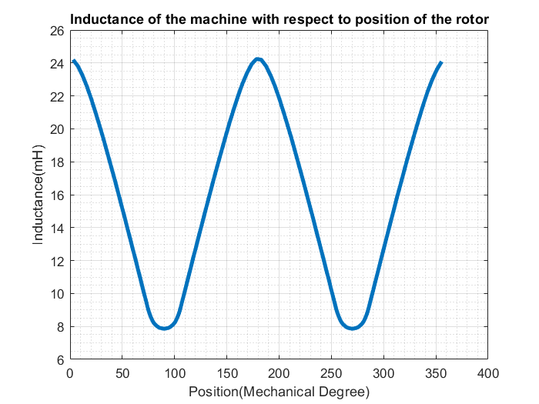

Figure Inductance of the machine with respect to rotor positions

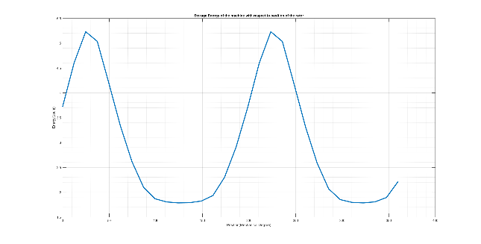

Figure Stored energy of the machine with respect to rotor positions

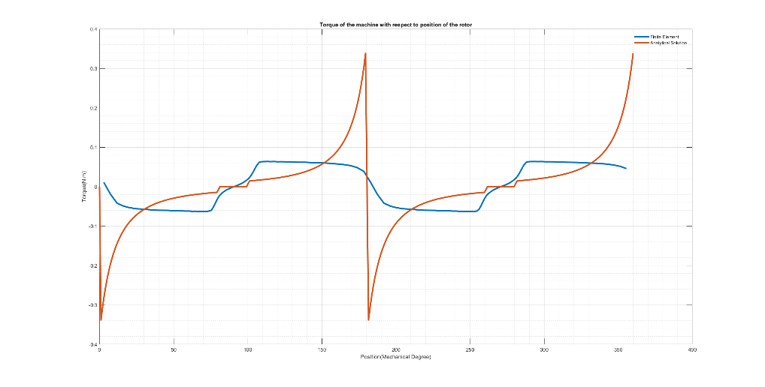

Figure Comparison of Electrical Torque of the machine with respect to rotor positions

|  |  |  |
| --- | --- | --- |
| Model | sin( ) | sin(4) |
| Analytical | 76.46 mN.m | 55.67 mN.m |
| Finite Element | 74.05 mN.m | 2.526 mN.m |

# Control Method

For analytical and finite element analysis shows the torque characteristic of the DC excitation. We can use the characteristic of the torque can be used for inductance characteristic actually. Then, we can calculate the torque by the inductance.

In my control system, the second harmonic is mainly controlled and additional torque from other harmonics are ignored. Inductance is taken as:

We observed that DC excitation does not give net torque and it make the machines oscillate, not fully rotate. Then, we can excite the winding sinusoidal as:

Thus, torque can be calculated as:

are expended and the torque can be calculated as:

Torque is formulized with respect to electrical frequency, mechanical speed and rotor initial position. By considering the equation, we can say that the machine produces net torque if electrical speed and mechanical speed is equal and initial position is not aligned. For initial speed is zero, we can drive the machine by starting low frequency excitation and increasing the electrical frequency with respect to desired speed.

# Conclusion

In this report, the variable reluctance machine is investigated. Firstly, analytical analysis is created to calculate inductance and torque with respect to position. The analytical solutions are not corrected but it gives fast solution. Also, we observe that assumptions for easy calculation led the result diverge the realistic solution. Secondly, finite element analysis is done with linear and nonlinear material. In this part, we learnt that finite element analysis gives better results but the simulation times are much bigger than analytical solution. Finally, the control method is proposed to rotate motor. DC excitation does not give fully rotation, it led the motor oscillate between initial position and its symmetric positions.

To conclude, the variable reluctance machine can be modelled by analytically or finite element analysis to observe electrical torque of the machine. Finite element analysis gives better results.

APPENDIX

* Analytical Model is given at the page.
* FEA-Maxwell is given at the page.
* Bonus part is given in page.